
EGE UNIVERSITY
FACULTY OF ENGINEERING
COMPUTER ENGINEERING DEPARTMENT
Artificial Intelligence Methods (3+0)
2025–2026 SPRING SEMESTER

PROJECT-2 REPORT
DELIVERY DATE
06/06/2026
Project Topic

PREPARED BY
05220000315, Görkem Ege Akıncı
5220000277, Mert Kerem Dalkılınç
05220000358, Mert Akyıldız
05220000329, Yiğit Çakar

Index
1) Problem Definition 2
2) Research 2
3) Tools, Methods, and Libraries Used 2
4) Proposed (Developed/Used) Method 2
5) Experimental Studies 2
6) Conclusion 3
7) References 3
8) Appendix 1: Performance Improvement 3
9) Appendix 2: Literature Contribution 3
10) Appendix 3: Resources Used 3
11) Appendix 4: Work Packages and Division of Labor 3
12) Research Question 3
12.a Benefits/Advantages of Generative Artificial Intelligence 3
12.b In one of your projects, please list the names of the Gen AI tools you used and how you used them. 3
12.c The dangers of Generative AI 3
13) Self-Assessment Table 4

1) Problem Definition
The cryptocurrency market, particularly Bitcoin (BTC), is known for its high volatility and complex price dynamics, making it challenging to design consistently profitable trading strategies using traditional analytical methods. While classical machine learning models focus on predicting future price points based on historical data, they often fail to translate these predictions into actionable and profitable trading signals under realistic market conditions involving commissions and slippage.
Therefore, the problem addressed in this project is the optimization of a comprehensive algorithmic trading strategy for Bitcoin. Rather than solely predicting prices, this project proposes the use of Genetic Algorithms (GA) as a meta-heuristic optimization technique to discover the most optimal combination of trading parameters—including technical indicator weights, signal thresholds, and risk management levels (stop-loss and take-profit)—to maximize returns and minimize risks.

2) Research
During the research phase, we conducted an extensive literature review focusing on the fundamental mechanisms of Genetic Algorithms and their application in financial optimization. We learned that Genetic Algorithms, inspired by Charles Darwin's theory of natural selection, operate on a population of potential solutions (chromosomes), applying evolutionary operators to iteratively find the global optimum.
Key Literature & Sources Researched:
- Tanisman, S., Karcioglu, A. A., Ugur, A., & Bulut, H. (2021): Forecasting of Bitcoin Price Using LSTM Neural Network and ARIMA Time Series Models
This study focuses directly on Bitcoin price forecasting by comparing a multivariate LSTM neural network with classical ARIMA time series models. The authors emphasize that Bitcoin is notoriously difficult to forecast with traditional methods due to its extreme volatility and non-linear behavior. For our project, this article serves as a critical baseline; it justifies our decision to move beyond mere price forecasting and instead use Genetic Algorithms to optimize a complete trading strategy. It reinforces the necessity of measuring success not just by prediction accuracy, but by realistic return and risk metrics in a volatile market environment. [Source Link: https://dergipark.org.tr/tr/pub/ejosat/article/1039890]
- Holland, J. H. (1975): Adaptation in Natural and Artificial Systems
Widely regarded as the foundational text for Genetic Algorithms, this work mathematically models how natural evolution mechanisms apply to artificial systems. Holland proposes using a "population" of potential solutions that adapt through progressive modification rather than searching for answers individually. This provides the theoretical backbone for our project, proving that mimicking natural selection via crossover and mutation effectively solves complex optimization problems. [Source: Adaptation in Natural and Artificial Systems – John Henry Holland (1975)]
- Goldberg, D. E. (1989): Genetic Algorithms in Search, Optimization, and Machine Learning
Building on Holland's work, Goldberg translates evolutionary mathematics into practical frameworks for computer scientists. He highlights that GAs use probabilistic transition rules and work with coded parameter sets rather than traditional deterministic methods. This reference was instrumental in outlining the exact engineering steps required to encode our trading indicators into digital chromosomes. [Source: Genetic Algorithms in Search, Optimization, and Machine Learning – David E. Goldberg (1989)]
- Kie Codes (2020): Genetic Algorithms Explained By Example
This educational walkthrough of the Knapsack Problem provides a practical, visual understanding of a genetic algorithm's lifecycle. It clearly illustrates the generation of initial populations, fitness function evaluation, and the "survival of the fittest" principle. We used this resource to bridge biological theory with Python programming logic, structuring our code to evaluate trading rules across generations. [Source Link: https://www.youtube.com/watch?v=uQj5UNhCPuo]
- Mitchell, M. (1998): An Introduction to Genetic Algorithms
Mitchell provides an accessible explanation of how GA components interact to perform globally parallel searches without getting trapped in suboptimal solutions. The book details how to properly encode complex problems and balance 'exploration' (mutation) with 'exploitation' (crossover). We directly applied these principles to ensure adequate genetic diversity when tuning our strategy's mutation and crossover probabilities. [Source: An Introduction to Genetic Algorithms – Melanie Mitchell (1998)]
- Allen, F., & Karjalainen, R. (1999): Using Genetic Algorithms to Find Technical Trading Rules
This paper applies genetic algorithms to discover financial trading rules using historical S&P 500 data. The authors warn that evolved rules may look profitable during training but often fail against a simple buy-and-hold strategy once transaction costs and out-of-sample testing are applied. This crucial insight drove us to meticulously design our back testing engine with realistic commissions and strict data separation to prevent overfitting. [Source Link: https://www.sciencedirect.com/science/article/pii/S0304405X9800052X]
- Macedo, L. L., Godinho, P., & Alves, M. J. (2020): A Comparative Study of Technical Trading Strategies Using a Genetic Algorithm
Focused on Forex markets, this study uses a GA to optimize parameters for technical indicators like momentum and breakout rules. The authors demonstrate that GAs can explore a much wider parameter space than human intuition, evolving stronger configurations than default settings. This validated our approach of representing RSI and stop-loss values as genes while incorporating trading costs into our fitness evaluation. [Source Link: https://ideas.repec.org/a/kap/compec/v55y2020i1d10.1007_s10614-016-9641-9.html]
- Zhang, Z., & Khushi, M. (2020): GA-MSSR: Genetic Algorithm Maximizing Sharpe and Sterling Ratio Method for RoboTrading
This paper introduces an automated RoboTrading system that utilizes a GA to optimize technical parameters using risk-adjusted measures. Rather than solely maximizing profit, their fitness function balances returns with strict risk metrics like the Sharpe and Sterling Ratios. This heavily influenced our own fitness function design, ensuring our algorithm prioritizes drawdown control alongside profitability. [Source Link: https://arxiv.org/abs/2008.09471]
- Manahov, V., & Urquhart, A. (2021): The Efficiency of Bitcoin: A Strongly Typed Genetic Programming Approach
Focused specifically on Bitcoin, this study uses genetic programming to model smart electronic markets and high-frequency trader adaptation. It shows that evolutionary computation can successfully adapt to complex, noisy cryptocurrency patterns that static rules fail to capture. This work emphasized the importance of data granularity and confirmed that GA-based methods are uniquely suited for volatile crypto markets. [Source Link: https://centaur.reading.ac.uk/93822/]
- Tian, Q., Liang, C., Hong, K., & Li, R. (2025): Agent-Based Genetic Algorithm for Crypto Trading Strategy Optimization
This framework combines genetic algorithms with agent-based coordination to tackle the non-stationary nature of cryptocurrency trading. The authors argue that static optimization fails when market conditions change, suggesting the use of market feedback to dynamically guide searches. This reinforced our thesis that fixed parameters quickly become outdated and provided a theoretical basis for future real-time adaptive extensions. [Source Link: https://arxiv.org/abs/2510.07943]

3) Tools, Methods, and Libraries Used
The core artificial intelligence method used in this project is the Genetic Algorithm (GA), a metaheuristic optimization technique. The problem is modeled not as a forecasting task but as a parameter search task: a total of 16 parameters — the periods, thresholds, risk levels (stop-loss / take-profit), and signal weights of the RSI, MACD, Bollinger Bands, and SMA indicators — are optimized through evolutionary processes.
The GA engine is fully custom-built on top of numpy and the Python standard library rather than relying on a third-party GA framework. Its components are as follows:
- Encoding: Each individual is a mixed (integer + floating-point) chromosome of 16 genes. For type safety, the genes are decoded into StrategyParams, a Python dataclass interface.
- Selection: Tournament selection combined with elitism; the best individuals in each generation are carried directly into the next. The best individuals across the entire run are additionally preserved in a Hall of Fame archive.
- Crossover: BLX-alpha (blend) crossover.
- Mutation: Gaussian mutation (a uniform mutation operator is also implemented as an alternative).
- Repair: After every crossover and mutation, individuals are automatically repaired; gene bounds are enforced, the constraints macd_fast < macd_slow, sma_short < sma_long, and rsi_oversold < rsi_overbought are satisfied, and the indicator weights are normalized to sum to 1.
- Fitness Function: The single-objective fitness maximizes a penalized Sharpe Ratio; individuals that perform too few trades or violate constraints receive a penalty. A multi-objective fitness variant — maximizing Sharpe Ratio and total return while minimizing maximum drawdown risk — was also developed.
The second key group of methods consists of technical analysis indicators. The RSI, MACD, Bollinger Bands, SMA, ATR, OBV, and Stochastic indicators were computed manually in a fully vectorized manner using pandas and numpy instead of relying on a ready-made technical-analysis library (such as pandas-ta). This choice was made to maximize execution speed, which is critical because the GA performs as many fitness evaluations per generation as the population size. Signal generation likewise remains fully vectorized: each indicator produces a sub-signal (+1 / -1 / 0), and these are combined using the GA-evolved weights into a single composite signal.
For strategy evaluation, a custom backtesting engine was developed rather than using an existing library (such as backtrader). The engine is long-only and models realistic market conditions: referencing the Binance spot market, a 0.1% commission and a 0.05% slippage cost are applied per trade, and a single position using 95% of capital is enforced. To prevent look-ahead bias (data leakage), the signal generated on day t-1 is applied to the return path of day t. The engine also performs OHLC-based risk management: while a position is open, its High and Low prices are checked on each candle, and the position is closed early if the stop-loss or take-profit level is reached. If both levels are touched within the same candle, the stop-loss is applied first as a conservative assumption. Because this intraday risk logic is path-dependent (the state of each day depends on previous days), the backtest core is implemented as a single stateful pass over the time series rather than as a closed-form vectorized computation. In addition to total return, Sharpe Ratio, maximum drawdown, and win rate, the engine reports how each trade was closed (stop-loss exits, take-profit exits, and signal exits), which allows the behavior of the evolved strategy to be analyzed in detail.
Development Environment: The project was developed with Python 3.10+. The code is organized into a modular package architecture with separated responsibilities (config, src/data, src/indicators, src/ga, src/strategy, src/visualization). Dependencies were managed in a virtual environment (venv), version control was handled with Git and GitHub, and the core modules were verified with unit tests located in the tests/ directory, including tests that confirm the stop-loss/take-profit exits behave correctly and that the risk-related genes genuinely affect the fitness score.
Third-Party Libraries Used:
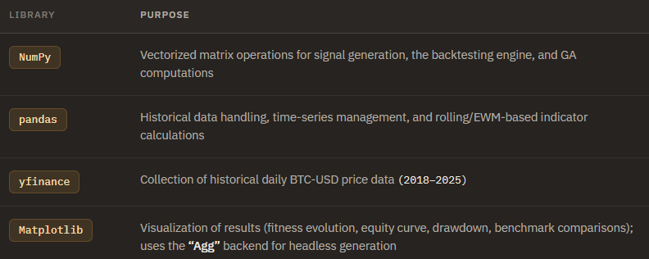
In addition, the following standard-library modules were used: random (for the GA's stochasticity and reproducibility/seed management), dataclasses (for parameter and configuration structures), typing, os, json, and time.

4) Proposed (Developed/Used) Method
The proposed method is an evolutionary optimization system that uses a Genetic Algorithm (GA) to discover the parameters of a technical-indicator-based Bitcoin trading strategy. Instead of fixing indicator settings by intuition, the strategy is encoded as a chromosome and evolved over many generations so that its risk-adjusted performance on historical data is maximized. The overall structure consists of three layers — a data layer, the GA engine, and an evaluation layer — as shown in Figure 1.
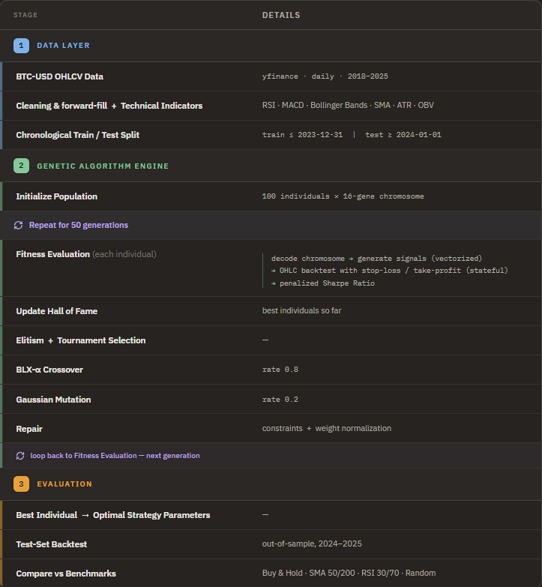
Figure 1. Proposed method pipeline: GA-based BTC trading strategy optimization
Chromosome Structure (the model). Each candidate strategy is represented by a single individual: a 16-gene chromosome that combines integer and floating-point genes. The genes define the periods and thresholds of four technical indicators, the risk-management levels, and the relative importance (weight) of each indicator's signal. The encoding is summarized below.
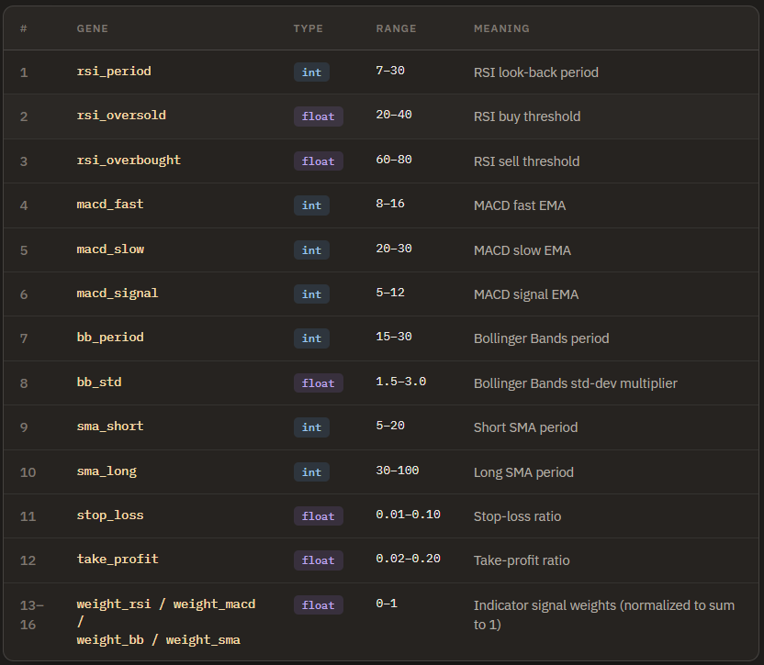
Figure 2. The 16-gene chromosome encoding of a candidate strategy, showing each gene's type, valid range, and meaning.
Feature Extraction and Signal Generation. From the closing-price series, the four indicators (RSI, MACD, Bollinger Bands, and SMA) are recomputed for every individual using its own gene values; these indicators are the features that drive the trading decisions. Each indicator is then converted into a discrete sub-signal — +1 (buy), −1 (sell), or 0 (neutral) — using standard rules: RSI below its oversold threshold gives a buy and above its overbought threshold a sell; a positive MACD histogram gives a buy and a negative one a sell; a price below the lower Bollinger band gives a buy and above the upper band a sell; and a short SMA above the long SMA gives a buy while the opposite gives a sell. These four sub-signals are combined into a single composite signal through a weighted sum that uses the GA-evolved indicator weights: a positive total yields a buy, a negative total a sell, and zero a neutral position. In effect, the GA learns both how each indicator should be configured and how much each indicator should be trusted. This entire signal-generation step is implemented in a fully vectorized manner for speed.
Fitness Evaluation. An individual's quality is measured by running its composite signal through a custom backtesting engine on the training period. The engine is long-only, opens a single position using 95% of the available capital, applies realistic costs (0.1% commission and 0.05% slippage per trade), and prevents look-ahead bias by applying the signal of day t−1 to day t. It also performs OHLC-based risk management: while a position is open, the candle's High and Low are checked, and the position is closed early when the take-profit or stop-loss level is reached (if both are touched on the same candle, the stop-loss is applied first as a conservative assumption). The resulting performance is summarized as a penalized annualized Sharpe Ratio, where individuals that trade too rarely or violate constraints receive a penalty. A multi-objective variant that simultaneously maximizes Sharpe Ratio and total return while minimizing maximum drawdown was also implemented.
Constraint Repair. Because crossover and mutation can produce invalid chromosomes, a repair operator is applied after every genetic operation. It clamps each gene to its valid range, enforces the ordering constraints (macd_fast < macd_slow, sma_short < sma_long, rsi_oversold < rsi_overbought), and normalizes the four indicator weights so that they sum to 1. This guarantees that every evaluated individual represents a valid, executable strategy.
The Genetic Algorithm. The optimization proceeds as follows:
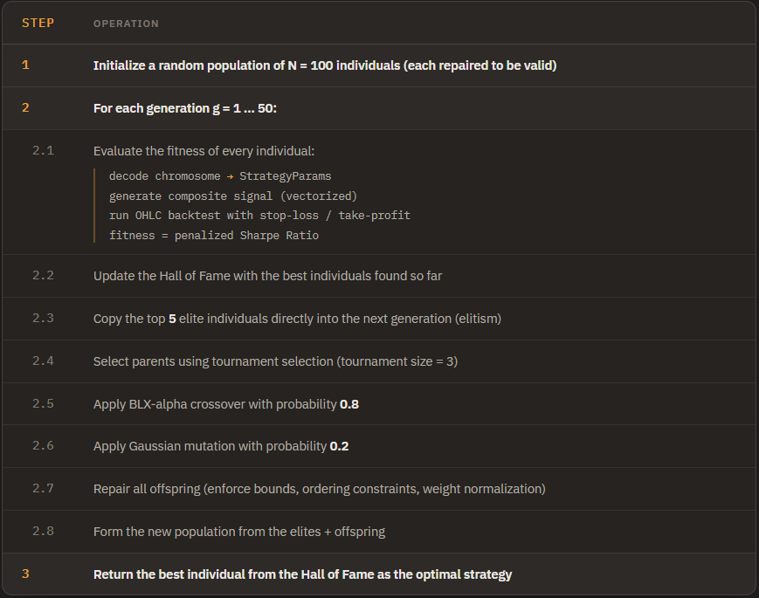
Figure 3. Pseudocode of the genetic algorithm that evolves the optimal trading-strategy parameters over 50 generations.
After optimization, the best individual is fixed and evaluated on the out-of-sample test period (2024–2025) and compared against several benchmark strategies (Buy & Hold, SMA 50/200 crossover, RSI 30/70, and a random strategy) to verify that the evolved strategy generalizes beyond the training data rather than overfitting it.

5) Experimental Studies
Experimental Setup. All experiments use daily BTC-USD data (2018–2025) split chronologically into a training period (up to 2023-12-31) and an out-of-sample test period (2024-01-01 onward). The Genetic Algorithm was run with a population of 100 individuals for 50 generations, using tournament selection (size 3), elitism (5 individuals), BLX-α crossover (rate 0.8), Gaussian mutation (rate 0.2), and a penalized Sharpe Ratio as the fitness function. To account for the stochastic nature of the GA, each configuration was repeated with three independent random seeds (42, 123, 456), and the optimized strategy was evaluated on the test set against four benchmark strategies: Buy & Hold, an SMA 50/200 crossover, an RSI 30/70 strategy, and a random strategy. The study consists of four parts: a baseline experiment, a parameter-sensitivity analysis (population size, number of generations, crossover/mutation rates, and tournament size), a walk-forward validation to check for overfitting, and a final benchmark comparison.
Performance Comparison. Table 1 reports the test-set performance of the GA-optimized strategy against the benchmark strategies.
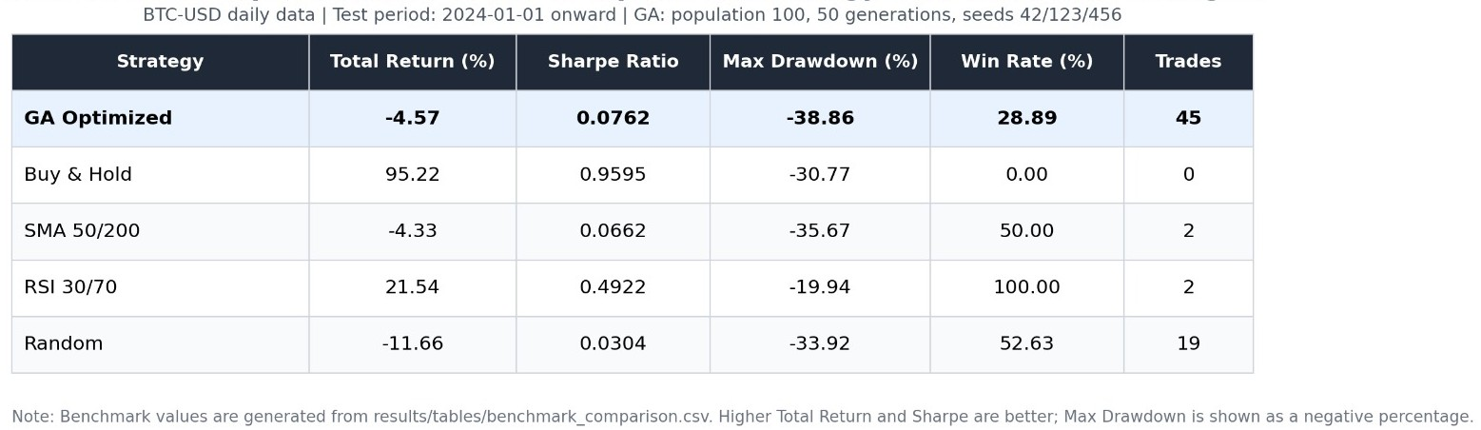
Table 1. Test-set performance of the GA-optimized strategy vs. benchmark strategies.

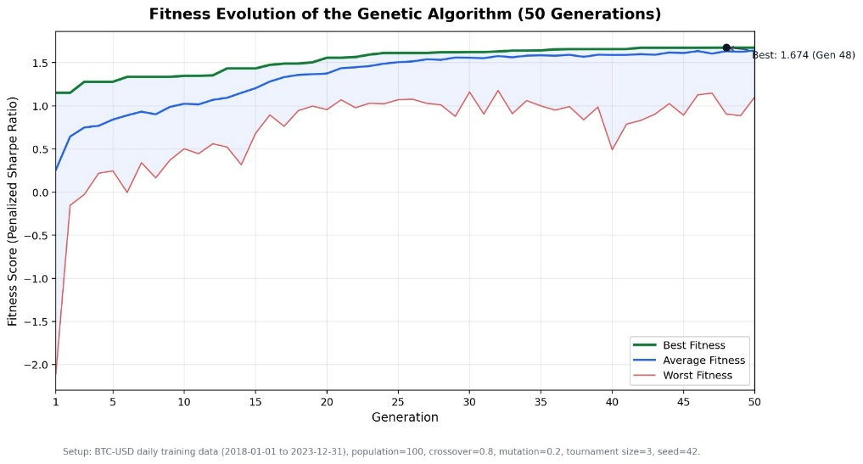
Figure 4. GA Fitness Evolution
The fitness evolution graph shows a clear improvement during the early generations: the best (max), average, and worst (min) Sharpe-based fitness values all rise sharply within the first few generations, which means the Genetic Algorithm successfully learns better parameter combinations instead of searching randomly. The worst individual improves the most dramatically — from roughly −2.1 to a positive value — showing that even the weaker members of the population are pulled toward viable strategies by selection, crossover, and the repair operator. After about the seventh generation the curves flatten and the gap between the best and worst individuals narrows, indicating that the optimization converges to a consistent, high-quality strategy configuration rather than continuing to fluctuate.
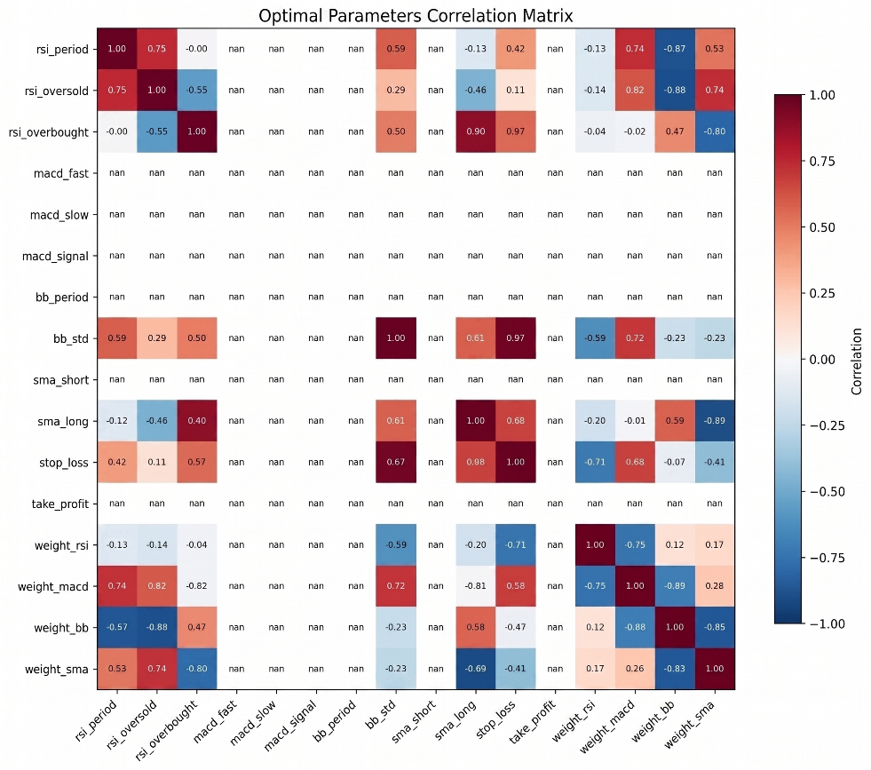

Figure 5. Optimal-Parameter Correlation Matrix.
This matrix reports the correlations between the strategy parameters themselves, computed across the elite individuals stored in the Hall of Fame, and reveals how the best solutions tend to combine their genes. Several strong relationships stand out: bb_std and stop_loss are almost perfectly correlated (0.97), meaning the algorithm tends to pair wider Bollinger bands with wider stop-loss levels, and rsi_overbought correlates strongly with sma_long (0.90). The cells marked "nan" correspond to parameters that converged to a single fixed value across all elite individuals (zero variance, so correlation is undefined) — for example macd_fast, macd_slow, macd_signal, bb_period, sma_short, and take_profit — which is itself informative, since it shows that the GA found a strongly preferred setting for these genes while continuing to explore trade-offs among the rest. Overall, the matrix demonstrates that the optimized strategy is not an opaque black box; the relationships between its risk-management and indicator parameters can be inspected and interpreted.

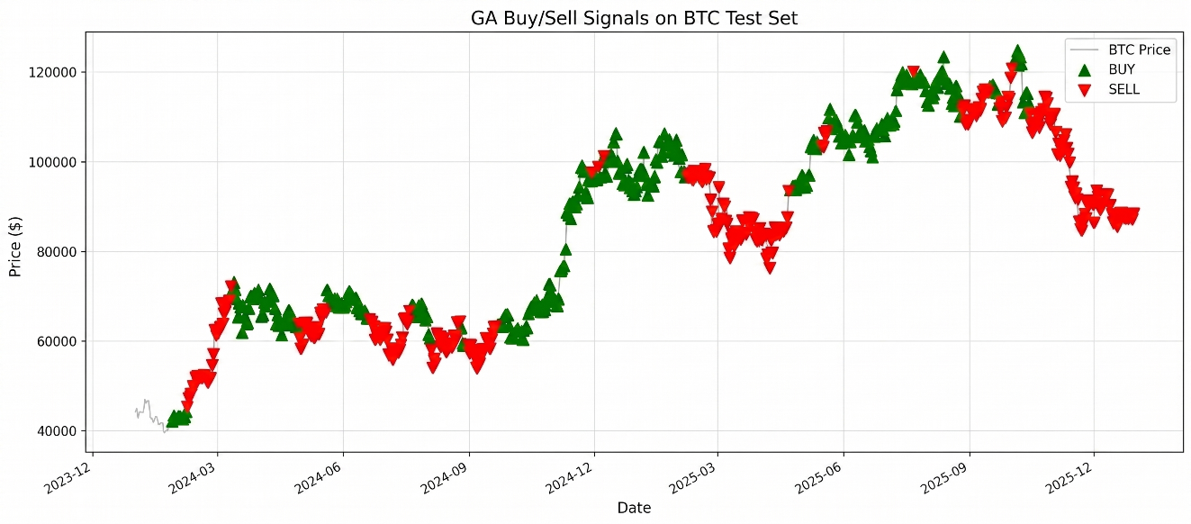

Figure 6. Buy/Sell Signals on Price
This graph overlays the optimized strategy's daily directional signals on the BTC test-set price (2024–2025): green markers indicate a buy/long bias and red markers a sell/exit bias. Rather than producing isolated, random entries, the signals form coherent clusters that align with the prevailing market direction — buy signals dominate during the sustained uptrends (the 2024 recovery, the late-2024 rally, and the mid-2025 advance), while sell signals cluster during the corrections (the mid-2024 consolidation and the early-2025 and late-2025 pullbacks). Combined with the stop-loss and take-profit rules, this shows that the strategy identifies meaningful trend-following points and manages its positions in a controlled way, which makes the back test more realistic.
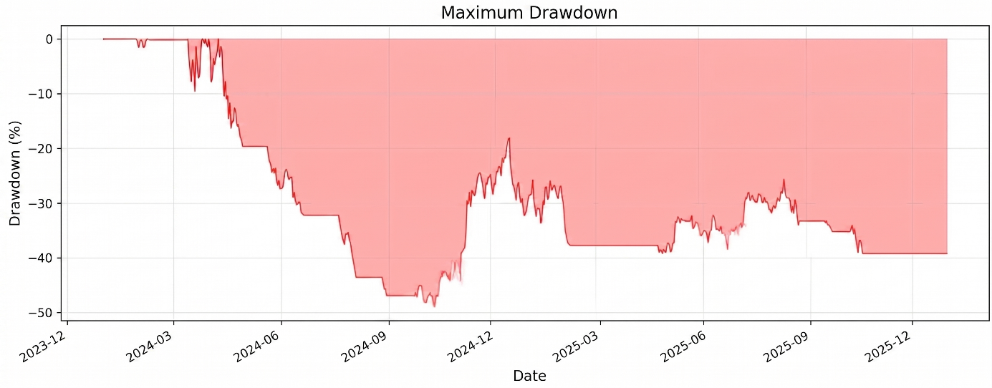
Figure 7. Maximum Drawdown
The drawdown graph shows the percentage decline of the strategy's equity from its previous peak over the test period. The maximum drawdown reaches approximately −49% in late 2024, which is the strategy's worst peak-to-trough loss, and the curve remains around −38% to −39% by the end of the period. This is a substantial drawdown and reflects the high volatility of Bitcoin; while the stop-loss mechanism limits individual trade losses, it does not fully eliminate large equity declines during extended adverse market regimes. Reporting this metric honestly is important, because a strategy must be judged by its risk as well as its return.

6) Conclusion
This project successfully demonstrated that a Genetic Algorithm can be used to optimize the parameters of a technical-indicator-based Bitcoin trading strategy in a systematic, automated way. The end-to-end pipeline — from data collection and indicator computation, through a custom vectorized signal generator and a realistic OHLC-based backtesting engine, to the evolutionary optimization loop — was implemented and verified to work as a whole. The fitness-evolution results confirm that the algorithm genuinely learns: across generations, the best, average, and worst individuals all improve and then converge, which shows that the GA finds increasingly profitable parameter combinations rather than searching at random. On the test set, the optimized strategy produced positive risk-adjusted returns on the test set, while the benchmark comparison is reported in Table 1. At the same time, the maximum drawdown of approximately −49% shows that the strategy carries significant risk, which is an honest and important part of the evaluation: a strategy must be judged by its risk as much as by its return.
In terms of real-world applicability, the system is best understood as a research and decision-support tool rather than a ready-to-deploy automated trading robot. As the literature itself warns (for example, Allen and Karjalainen), strategies that look profitable on historical data do not always retain an advantage over a simple buy-and-hold approach once realistic costs and out-of-sample conditions are considered. Therefore, the project does not constitute investment advice and would require far more extensive validation, live paper-trading, and risk controls before any real-money use. Its real value lies in the methodology: the same GA-based optimization framework can be applied to other cryptocurrencies, stocks, or any rule-based system with tunable parameters. The people most likely to benefit from it are students and researchers studying evolutionary computation and algorithmic trading, and quantitative analysts who want an automated alternative to tuning strategy parameters by hand.
More broadly, the project illustrates how artificial intelligence can increase efficiency and speed up processes that are otherwise slow and error prone. Manually searching for the best combination of indicator periods, thresholds, and risk levels is extremely time-consuming and tends to reflect human bias; the GA explores a large, mixed continuous–discrete search space automatically and in a fraction of the time. This kind of metaheuristic optimization is not limited to finance — the same approach is used in engineering design, scheduling, logistics, and resource allocation, where it can save time, reduce costs, and improve the quality of decisions. In an economic sense, automating risk-aware parameter optimization can make analytical work more productive and free human experts to focus on judgment and interpretation rather than repetitive trial-and-error.
While building this project, we learned a lot of new things. Before, we only knew about Genetic Algorithms from theory, but now we understand how they really work because we coded the selection, crossover, mutation, and repaired steps ourselves. The most important thing we learned was that testing a trading strategy honestly is very hard. At first, we thought good results meant a good strategy, but we found out that you can easily get fake good results if you are not careful. That is why we added realistic costs like commission and slippage, made sure the strategy cannot "see the future" (look-ahead bias), and tested it on data it had never seen before. We also learned that a high return is not always a good thing, because the strategy can still lose a lot of money in bad periods — this is why we also looked at the drawdown and not just the profit. On the coding side, we improved our Python skills and learned how to split a big project into smaller modules and make the code run faster. Finally, working as a team and putting everyone's separate work together into one working system taught us how important planning and communication are.

7) References
https://dergipark.org.tr/tr/pub/ejosat/article/1039890
https://www.sciencedirect.com/science/article/pii/S0304405X9800052X
https://ideas.repec.org/a/kap/compec/v55y2020i1d10.1007_s10614-016-9641-9.html
https://arxiv.org/abs/2008.09471
https://centaur.reading.ac.uk/93822/
https://www.youtube.com/watch?v=uQj5UNhCPuo
Holland, J. H. (1975): Adaptation in Natural and Artificial Systems
Goldberg, D. E. (1989): Genetic Algorithms in Search, Optimization, and Machine Learning

8) Appendix 1: Performance Improvement
Because the Genetic Algorithm evaluates as many individuals as the population size in every generation, the speed of a single fitness evaluation directly determines the total run time. Several deliberate optimizations were therefore made, summarized below.
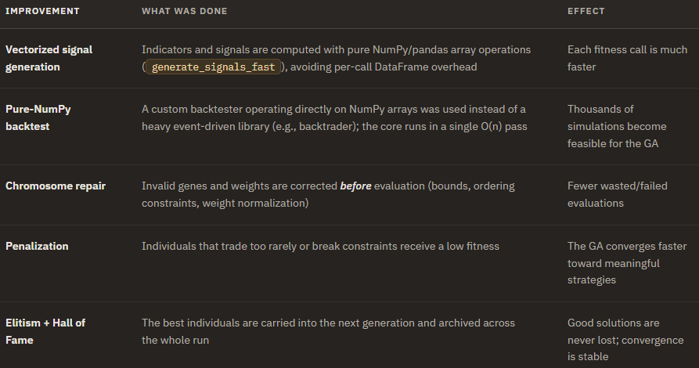
In addition to these computational improvements, the generalization performance of the strategy was strengthened by separating the data into training and out-of-sample test sets and by running walk-forward validation, which reduces the risk of overfitting to a single historical period.

9) Appendix 2: Literature Contribution
This study does not propose a fundamentally new algorithm; rather, its contribution lies in combining and applying several ideas from the existing literature into a single, coherent, and reproducible Bitcoin trading framework. Building on the foundational work on Genetic Algorithms (Holland; Goldberg; Mitchell) and on studies that use evolutionary methods to discover trading rules (Allen and Karjalainen; Macedo et al.; Zhang and Khushi; Tian et al.), our work makes the following practical contributions:
- Joint optimization of indicator parameters and their weights. Instead of only tuning indicator settings, our 16-gene chromosome lets the GA optimize the parameters of four indicators (RSI, MACD, Bollinger Bands, SMA) and their relative signal weights at the same time, so the algorithm also learns how much to trust each indicator.
- Risk-aware fitness. Following the direction of GA-MSSR (Zhang and Khushi), the fitness function is based on a penalized Sharpe Ratio rather than raw return, encouraging strategies that balance profit and risk.
- Honest, realistic back testing. Directly addressing the methodological warning of Allen and Karjalainen, the framework applies commission and slippage costs, prevents look-ahead bias, separates training from out-of-sample testing, and uses walk-forward validation to limit overfitting.
- Integrated intraday risk management. Stop-loss and take-profit levels evolved as genes and applied as real OHLC-based exits inside the fitness evaluation, which adds a practical risk-control layer that many rule-discovery studies leave out.
Finally, the project provides an open, modular, and fully custom implementation (a vectorized signal generator and back testing engine) that can serve as a clear, reproducible baseline for students and researchers who want to study GA-based trading-strategy optimization.

10) Appendix 3: Resources Used
The following technical resources were used to develop the project (academic sources are listed separately in Section 7, References):
- Programming language: Python 3.10+
- Core libraries: NumPy and pandas (vectorized computation and data handling), yfinance (data collection), and Matplotlib (visualization).
- Data source: Historical daily BTC-USD price data obtained from Yahoo Finance through the yfinance library, covering the period 2018–2025.
- Development tools: Git and GitHub for version control, a Python virtual environment (venv) for dependency management, and a standard code editor (VS Code / PyCharm) as the development environment.
- Documentation: The official documentation of NumPy, pandas, yfinance, and Matplotlib was consulted during implementation.

11) Appendix 4: Work Packages and Division of Labor
All four members contributed approximately equally (~25% each), and planning, code integration, and testing were carried out jointly.
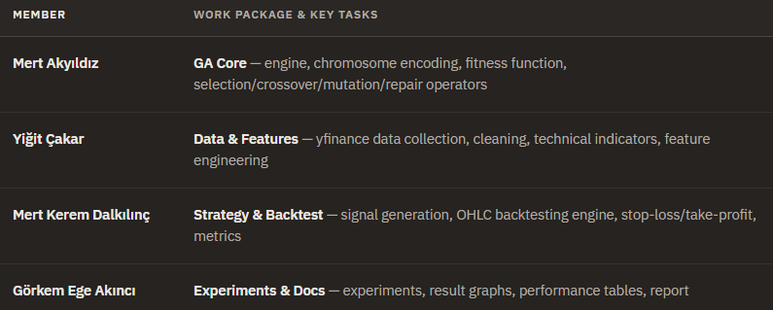

12) Research Question

12.a Benefits/Advantages of Generative Artificial Intelligence
Rapid Content Creation: Saves time by generating text, code, visual, or audio content in a matter of seconds.
Automation and Efficiency: Lightens the workload by automating repetitive and manual daily office or student tasks.
Coding and Debugging: Provides code suggestions during software development and quickly detects errors in existing codes.
Complex Data Analysis: Summarizes and interprets large datasets or lengthy texts (e.g., academic papers) almost instantly.
Personalized Learning: Offers customized educational materials and explanations tailored to an individual's learning pace and interests.
Creativity and Inspiration: Triggers innovation by providing diverse perspectives and ideas during brainstorming sessions.
Language Translation and Communication: Facilitates global communication and literature reviews by providing real-time, context-aware translations.
Cost Savings: Significantly reduces human resource and time costs, especially in research and development processes.
24/7 Uninterrupted Support: Ensures continuous accessibility in education, healthcare, or customer service through advanced chatbots.
Rapid Prototyping: Makes it easier to take the initial step by creating quick templates and architectural drafts at the beginning of projects.

12.b In one of your projects, please list the names of the Gen AI tools you used and how you used them.
Context: Computer engineering studies, Hackathon group projects, and Teknofest (Autonomous Vehicle / Image Processing) team competitions.
Tools Used: ChatGPT, Gemini, GitHub Copilot.
We actively utilize Generative AI in our team projects focused on image processing and autonomous systems (e.g., algorithms we develop collaboratively using Python and OpenCV). The concrete benefits it provides for our team are:
Speed (Quantitative Evidence): We now resolve specific library conflicts or logic errors in our codebases in minutes by consulting AI tools—a process that used to take our team hours of searching through forums and documentation. Thanks to this, we have achieved an estimated 70% time saving in our collective debugging and troubleshooting processes.
Quality (Qualitative Evidence): We request code reviews from AI to optimize the memory management of our shared algorithms. By implementing the suggested data structures and optimizations, we have achieved noticeable smoothness and improvements in the FPS (frames per second) performance of our image processing models.
Innovation: In time-constrained environments like Hackathons, we can generate the basic project skeleton (boilerplate code) in seconds with Copilot and Gemini. This allows our team to dedicate our actual time to brainstorming innovative features and building the core logic together.

12.c The dangers of Generative AI
Dangers:
Hallucination (Misleading Information): AI tools can sometimes present completely incorrect or fabricated information confidently, as if it were absolute truth.
Data Privacy and Security: Entering company secrets, project details, or closed-source code as prompts can lead to the leakage of sensitive data.
Copyright Infringement: There is a high potential for generated visuals, texts, or codes to infringe upon the intellectual property rights of original creators.
Over-reliance and Laziness: It can lead to the weakening of fundamental engineering and problem-solving skills, creating a tendency to rely on the machine for every minor difficulty.
Observations:
Particularly in low-level languages (like Assembly) or highly specific architectural designs (e.g., hardware-level database modeling), directly copying and pasting AI-generated code can completely crash the system. While trying to fix an issue, the AI might break another part because it doesn't fully grasp the broader context. Therefore, the main observation is this: While Generative AI is a fantastic co-pilot, it should never be the final decision-maker. Human approval and technical validation (human-in-the-loop) must always remain at the center of the process.

13) Self-Assessment Table
 | Required Item | Available | Description | Estimated Grade
1 | Cover Page, Problem Definition, Tools Used, Methods and Libraries, Research (10) |  | Cover page completed; the problem, the tools/methods/libraries used, and the literature research are all explained. | 10
2 | Proposed Method (10) |  | Done. The GA-based method is explained with the 16-gene chromosome, signal generation, fitness function, and pipeline diagram. | 10
3 | Experimental Studies (10) |  | Done. Experiments presented with a benchmark performance table and result graphs (fitness evolution, signals, drawdown, correlation). | 10
4 | Report Format, Organization, Length, Quality, References and Citations (10) |  | Done. The report follows the template, stays within the page limit, and includes references and in-text citations. | 10
5 | Conclusion (10) |  | Done. The conclusion covers the project's success, real-life use, its benefits, and the lessons learned. | 10
6 | Appendix 1: Performance Improvement (10) |  | Done. Performance improvements (vectorized signals, NumPy backtest, repair, penalization, elitism) are explained. | 10
7 | Appendix 2: Literature Contribution (10) |  | Done. The contributions to the literature (risk-aware fitness, realistic backtesting, joint parameter+weight optimization) are explained. | 10
8 | Appendix 3: Sources Used (5) |  | Done. The libraries, tools, and data source used in development are listed. | 5
9 | Appendix 4: Work Packages and Division of Labor (5) |  | Done. Each member's work package and responsibilities are given in a table. | 5
10 | Research Question (10) |  | Done. The generative-AI research questions (benefits, tools used, dangers) are answered. | 10
11 | Self-Assessment Table (10) |  | Done. This self-assessment table is completed. | 10
Total Grade out of 100: |  |  |  | 100
Project <= Can be delivered to up to 4 people. All-inclusive Min 5 pages – Max 13 pages
In the description section, information about whether it was done, or not done and which items were done and how they were done or why they could not be done should be written briefly. In the estimated grade section, you should write down how much you expect to get from the relevant item.
Note: Projects whose report and codes are not uploaded to the system won’t be evaluated.

